Candidate Privacy Notice

What is the purpose of this document?
Brigade Electronics Group PLC and Brigade Electronics UK Limited (“Brigade”, “we”, “us”, “our”) are "data controllers". This means that we are responsible for deciding how we hold and use personal information about you. This privacy notice (“Candidate Privacy Notice”) shall apply if you apply for a role with us (whether as an employee, worker, or contractor). It makes you aware of how and why your personal data will be used, namely for the purposes of the recruitment exercise, and how long it will usually be retained for. It provides you with certain information that must be provided under both the Retained Regulation (EU) 2016/679, United Kingdom General Data Protection Regulation (UK GDPR) and the General Data Protection Regulation, Regulation (EU) 2016/679 (EU GDPR).
Please be aware that we may provide you with other privacy notices on specific occasions when we are collecting or processing personal data about you. This Candidate Privacy Notice is not intended to exclude or supersede provisions in any such other privacy notices that may apply to you.

Data protection principles.
We will comply with data protection law and principles, which means that your data will be:
- Used lawfully, fairly and in a transparent way.
- Collected only for valid purposes that we have clearly explained to you and not used in any way that is incompatible with those purposes.
- Relevant to the purposes we have told you about and limited only to those purposes.
- Accurate and kept up to date.
- Kept only as long as necessary for the purposes we have told you about.
- Kept securely.

The kind of information we hold about you.
In connection with your application, we will collect, store, and use the following categories of personal information about you:
- The information you have provided to us in your curriculum vitae and covering letter including (but not limited to) name, title, address, telephone number, personal email address, date of birth, gender, ethnicity, employment history, qualifications, any reference to family members, right to work status, and any other personal details (achievements/travel history/willingness to relocate).
- Copy of your passport and/or driving licence.
- Any information you provide to us during an interview.
- Assessment and presentation responses, communications related to the recruitment exercise and any documents or other files you provide to us in connection with the recruitment and application process; and if you send us email messages or other communications, we will collect and retain those communications.
We may also collect, store, and use the following types of more sensitive personal information:
- Information about your race or ethnicity, religious beliefs, sexual orientation, disability, and political opinions.
- Information about your health, including any medical condition, health, and sickness records.
- Information about any unspent criminal convictions and/or driving offences.

How is your personal information collected?
We collect personal information about candidates from the following sources:
- You, the candidate.
- Recruitment agencies, from which we collect the following categories of data: CV, right to work in the UK, references, contact details (email/phone).
- Applications and services that make users' information available to others, such as LinkedIn Recruiter and other social networks. On some occasions third party job boards are used for candidate searches.
Once an offer for a role has been made, we collect personal information about you from the following sources:
- Credence, or such other provider as Brigade may use from time to time, from which we collect the below categories of data. The amount and type of data we collect will depend on the level of check carried out:
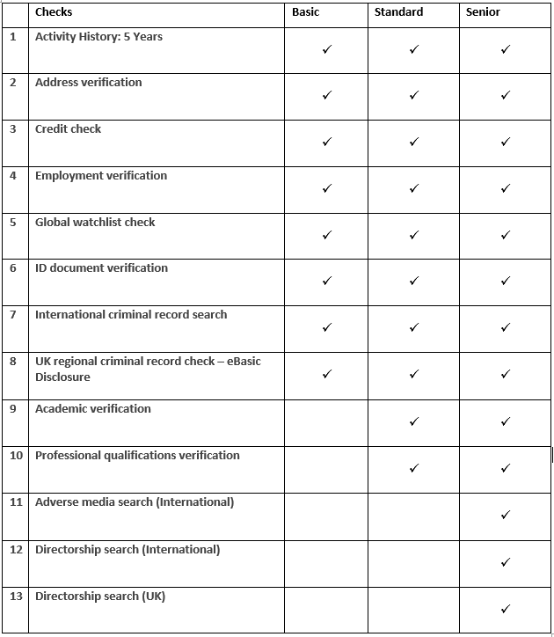

- Your named referee: whilst we take up references via Credence as a standard process, we may require character references for some roles.
- Thomas International Ltd, or such other provider as Brigade may use from time to time, from which we collect information on your personality profile.

How we will use information about you.

We will use the personal information we collect about you to:
- Assess your skills, qualifications, and suitability for the role.
- Carry out background and reference checks, for all successful applicants, the level of which depends upon the seniority of the role and its exposure to business data.
- Communicate with you about the recruitment process.
- Keep records related to our hiring processes.
- Comply with legal or regulatory requirements.

It is in our legitimate interests to use the data you have provided to help us decide whether it is appropriate and beneficial to appoint you to the role and whether to enter into a contract of employment with you.
Having received your CV and covering letter, we will then process that information to decide whether you meet the basic requirements to be shortlisted for the role. If you do, we will decide whether your application is strong enough to invite you for an interview. If we decide to call you for an interview, we will use the information you provide to us at the interview to decide whether to invite you for a second interview and following that interview and any applicable assessments to offer you the role. If we decide to offer you the role, we will then engage with Credence to carry out background checks on our behalf. These checks will include but not be limited to a basic criminal record check.

How we use particularly sensitive personal information.
We will use information about your disability status to consider whether we need to provide appropriate adjustments during the recruitment process, for example whether adjustments need to be made during a test or interview or if you have specific needs to access any of our buildings.

We may use information about your race or national or ethnic origin, religious, philosophical, or moral beliefs, or your sexual life or sexual orientation, if necessary, to serve the public interest (i.e if we are obligated to carry out equal opportunity monitoring and reporting obligations).

Information about criminal convictions.
Our business requires that anyone who takes a role with us, demonstrates a high degree of trust and integrity. As such, we have a legitimate interest to carry out a basic criminal record check of any unspent convictions to satisfy ourselves that there is nothing in your criminal convictions history which makes you unsuitable for the role that you have applied for, and to prevent unlawful acts in the business which could impact the welfare or well-being of the general public.
We have in place an appropriate policy document and safeguards which we are required by law to maintain when processing such data.
What if you decide not to provide us with your personal data for processing in the recruitment process?
You are under no statutory or contractual obligation to provide your data to us during the recruitment process. However, if you do choose not to provide the information, we may not be able to process your application properly or at all.
You are not obligated to provide to us any information on your race or national or ethnic origin, religious, philosophical, or moral beliefs, or your sexual life or sexual orientation, and there are no consequences for your application if you choose not to provide such information.

Automated decision-making.
You will not be subject to decisions that will have a significant impact on you based solely on automated decision-making.
Why might you share my personal information with third parties?
We will share your data internally, as necessary, for the purposes of the recruitment exercise as follows:
- Interviewers/line management (and their nominated delegates) involved in the recruitment process.
- Other internal teams as may occasionally require access to your personal data for the fulfilment of their roles related to the proper functioning of our company.
We also share certain information about you with third parties external to us, this may include, for example, the following types of disclosures:
- Any referees nominated by you.
- Any third parties involved in a shared recruitment activity.
- Credence, or such background check provider as we may use from time to time.
- Thomas International Ltd, or such personality assessments provider as we may use from time to time.

All our third-party service providers and other entities in the group are required to take appropriate security measures to protect your personal information in line with our policies. We do not allow our third-party service providers to use your personal data for their own purposes. We only permit them to process your personal data for specified purposes and in accordance with our instructions.

Data security.

We have put in place appropriate security measures to prevent your personal information from being accidentally lost, used, or accessed in an unauthorised way, altered, or disclosed. In addition, we limit access to your personal information to those employees, agents, contractors and other third parties who have a business need-to-know. They will only process your personal information on our instructions, and they are subject to a duty of confidentiality. Details of these measures may be obtained from the Data Protection Officer at privacy@brigade-electronics.com.
We have put in place procedures to deal with any suspected data security breach and will notify you and any applicable regulator of a suspected breach where we are legally required to do so.
How long will you use my information for?
We will retain your personal information for a period of 12 months after we have communicated to you our decision about whether to appoint you to a role. We retain your personal information for that period so that we can show, in the event of a legal claim, that we have not discriminated against candidates on prohibited grounds and that we have conducted the recruitment exercise in a fair and transparent way. After this period, we will securely destroy your personal information in accordance with our data retention policy.
If we wish to retain your personal information on file, on the basis that a further opportunity may arise in future and we may wish to consider you for that, we will write to you separately, seeking your explicit consent to retain your personal information for a fixed period on that basis.
Your rights in connection with personal information.
Under certain circumstances, by law you have the right to:
- Request access to your personal information (commonly known as a "data subject access request"). This enables you to receive a copy of the personal information we hold about you and to check that we are lawfully processing it.
- Request correction of the personal information that we hold about you. This enables you to have any incomplete or inaccurate information we hold about you corrected.
- Request erasure of your personal information. This enables you to ask us to delete or remove personal information where there is no good reason for us continuing to process it. You also have the right to ask us to delete or remove your personal information where you have exercised your right to object to processing.
- Object to processing of your personal information where we are relying on a legitimate interest (or those of a third party) and there is something about your particular situation which makes you want to object to processing on this ground. You also have the right to object where we are processing your personal information for direct marketing purposes.
- Request the restriction of processing of your personal information. This enables you to ask us to suspend the processing of personal information about you, for example if you want us to establish its accuracy or the reason for processing it.
- Request the transfer of your personal information to another party.
If you have any questions about this privacy notice, how we handle your personal information or if you want to exercise any of the rights set out in this section, please contact the Data Protection Officer in writing. You have the right to make a complaint at any time to the Information Commissioner's Office (ICO) who is responsible for data protection issues in the UK or you may raise your concerns with your local data protection authority directly.

